Report about our day trip to Monte Nuovo.
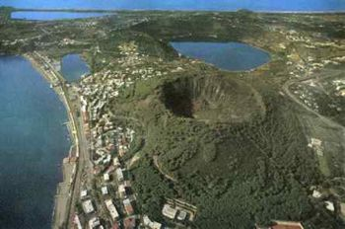
Monte Nuovo is a mount that belongs to
the area of Campi Flegrei. It has an incredible story: its formation, caused by a series of damaging earthquakes and changes in land elevation, lasted only one week (from September 29 to October 6, 1538).
It’s 133 m high and it has a diameter of 420 m.

On 27th March we went on an exciting day trip to Monte Nuovo, but previously, on 22nd,we had a meeting with a trekking expert, Pino Del Prete, who I actually thank because he made everything really interesting. He informed us about the program of the trip and he recommended us the correct outfit to wear, paying attention to the shoes, that had to be with non-smooth soles and this turned out to be very helpful. He also spoke about the importance of nature and he was so persuasive that made me do the countdown until the day of the trip.

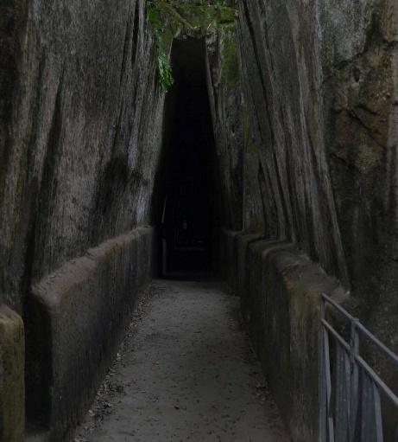
We met at 8 o clock and at about 9 we arrived at
Antro della Sibilla, a famous cave described by
Virgil in the Aeneid, that dates back to VII/VI century a.C.
According to the legend, the Sibyl was considered to
provide predictions or precognition of the future,
inspired by gods, in fact people left many offers at the entrance of the cave. The atmosphere of this place is actually unsettling, because it’s so dark and narrow.

Our guide got in the position where the Sibyl
standed and from that point the voice is actually
amplified. He told us that the secret of the Sibyl
was the fact that she gave answers that would
have been true in every case, that’s why today
we call “sibylline” something enigmatic.
The cave is entirely excavated in the tuff and it
has trapezoidal shape in the upper part,
an anti-seismic technical used by Greeks.
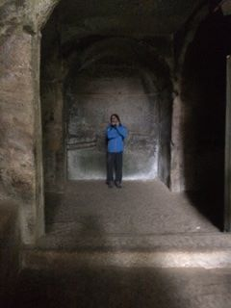

We also saw the Temple of Jupiter and the one of Apollo, both dated VI/V century a.C., which are mainly rests, but they appear attractive.

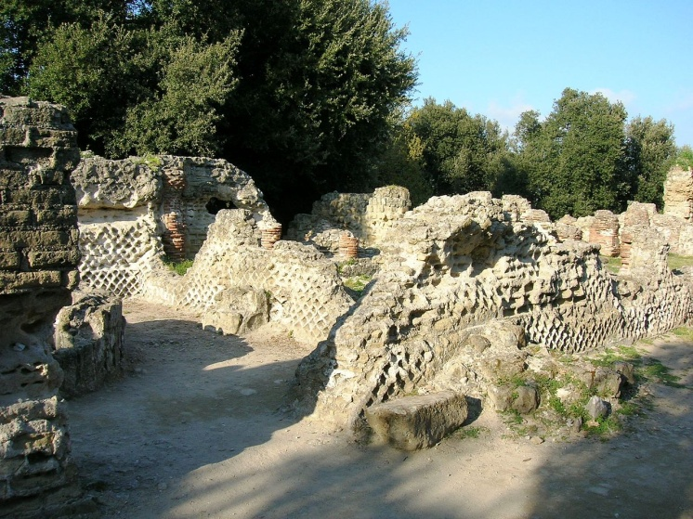
This temple was built on the former temple of Demeter, but there’s no witness that it was actually consecrated to Jupiter. Then it became a Christian basilica.
It was abandoned during the XIII century
and revisited in 1924.

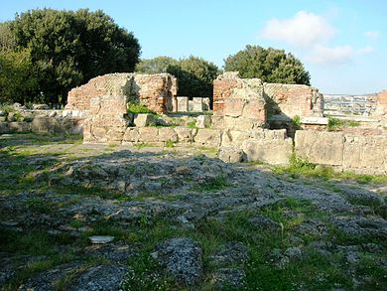
The Temple of Apollo was built on the former Temple of Era and then it was completely rebuilt during the roman age.

Finally we started our climbing to Monte Nuovo… It was amazing to get so close to nature.
The modifications of the flora are visible: we can notice plants that belong to an arid climate, like the Hiparrhenia hirta or the Ampelodesmos mauritanicus, but also, and above all, flora of the Mediterranean scrub, like the Myrtus communis and the Arbutus unedo. The crater is full of Quercus ilex and Quercus pubescens.
While we were climbing the mount, we had the opportunity to admire amazing views of our gulf:
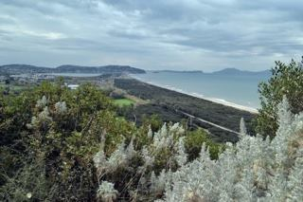
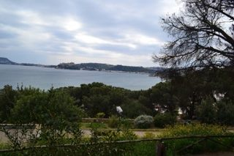

Some parts of the itinerary were quite difficult to pass through, but at the end we were all really satisfied. Once again, thank you Erasmus+ team!

