A Visit to Real Museo Mineralogico, Naples

To be introduced to the subject of our Erasmus Plus project “Trail of extinct and active volcanoes, earthquakes through Europe” we have visited The Real Museo Mineralogico (that is The Royal Museum of Mineralogy. See http://www.cmsnf.it/real-museo-mineralogico/), which is located in the heart of Naples inside the University of Naples in a XVII century library. We were accompanied by our Science teacher, Mrs. Castaldo.

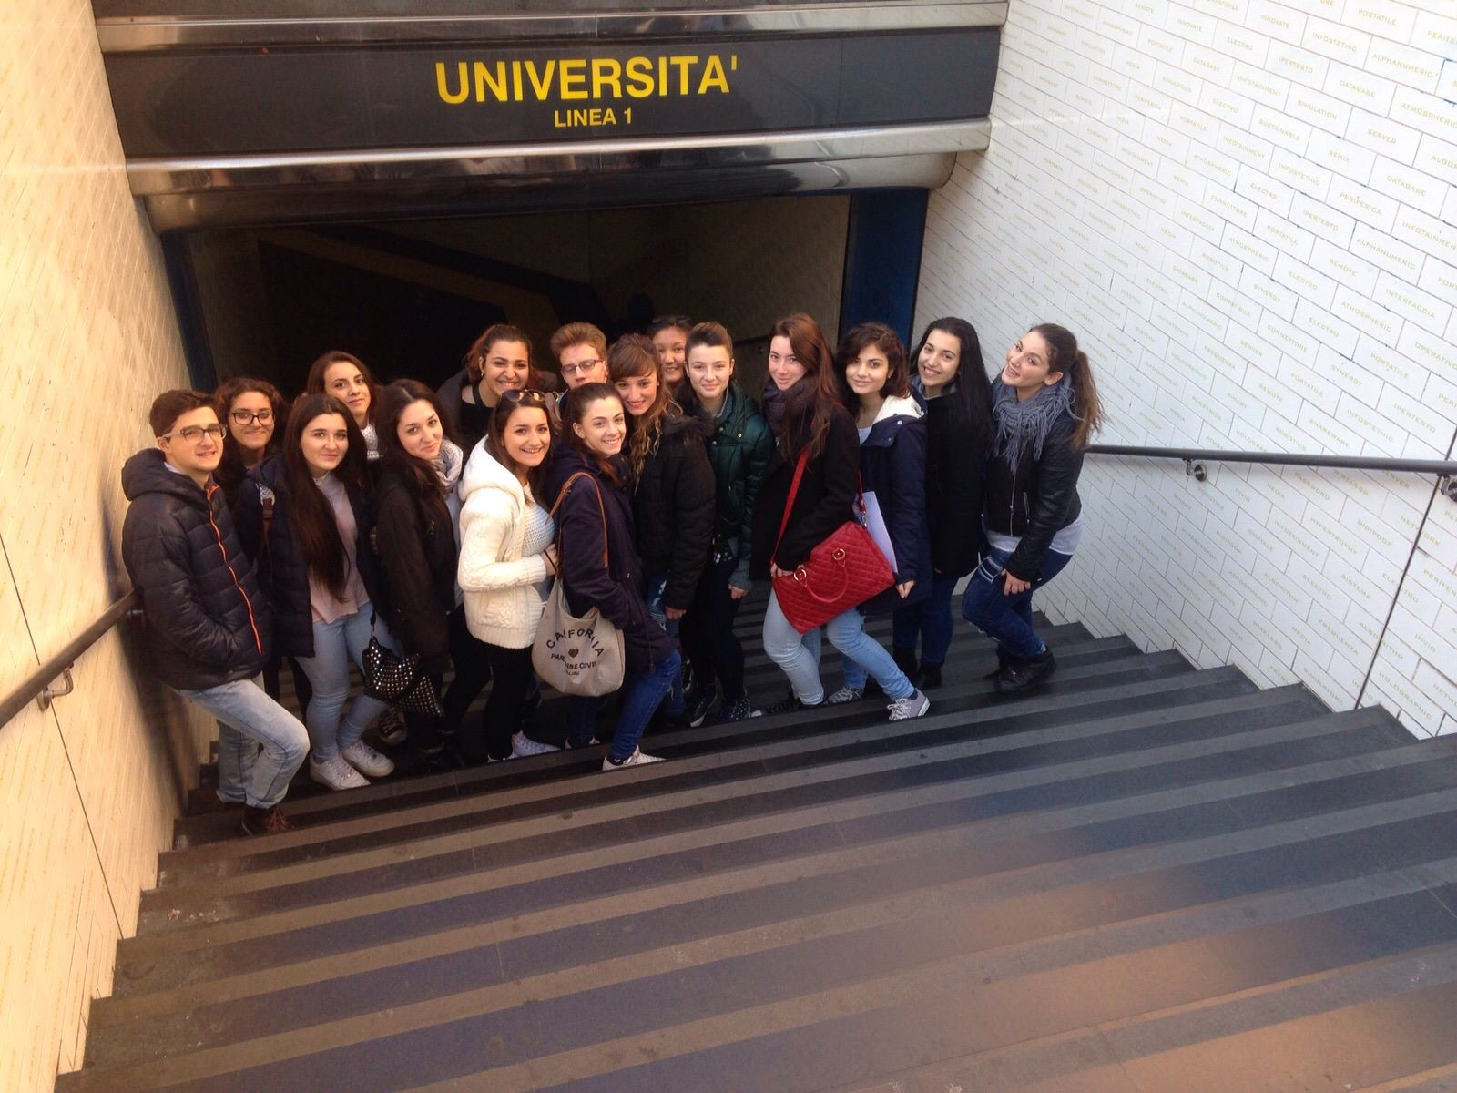
Erasmus+ Students

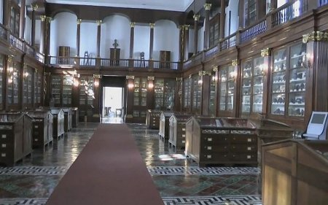
Real Museo Mineralogico Sala Sacchi

The museum collection is composed of 25, 000 exhibits representing different geological areas of the world. Amongst the different collections, the Vesuvian Collection is unique for its rarity and scientific relevance.
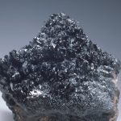
Haematite from Vesuvius

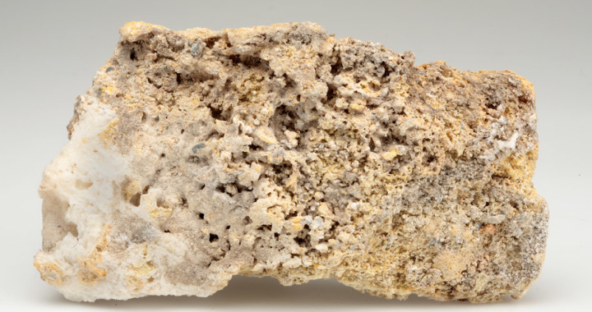
Coquimbite from Solfatara, Pozzuoli – Tufa from Campania Collection

Thanks to the guide who explained us everything we didn’t know, we have learned a lot of new things about crystals, stones and we have taken a lot of pictures, too. An interesting thing was a phenomenon to which some minerals are subjected to. These minerals, called fluorescent or luminescent, when radiated with ultraviolet light or X-ray, are capable of letting out temporarily luminous radiations different from those issued at the natural light.

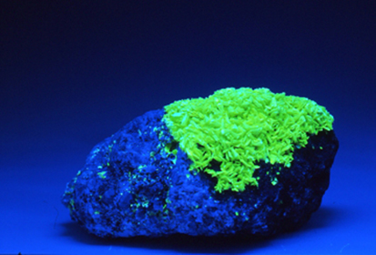
Fluorescent mineral

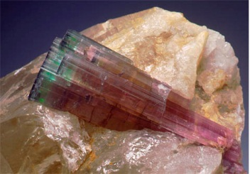
Tourmaline

We have also seen a lot of native elements such as the sulphur. About fifty-four standards of this element are exposed in the first three display cases and their colour is yellow. Most of them are from Sicily but also from the Aeolian Islands.

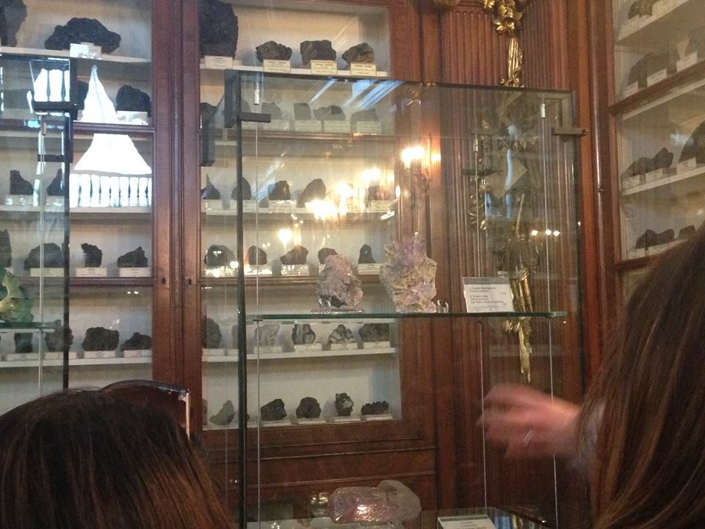

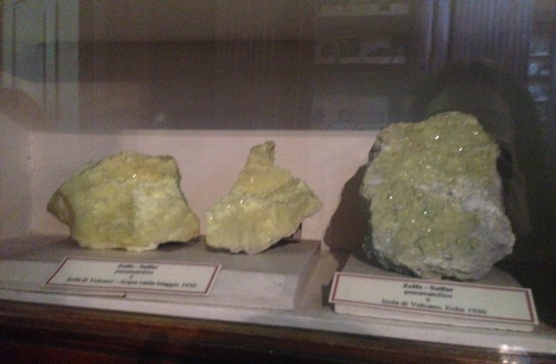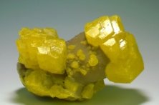
Sulphur

In the museum there were a lot of different crystals which come from all over the world such as: Rhodochrosite from Congo, Quartz from Hungary, Baryte from England and Garnet from Colorado.

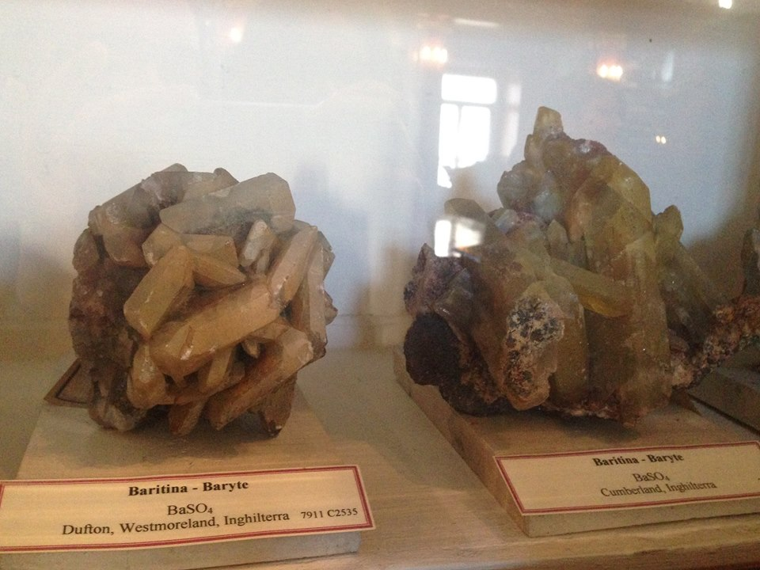
Baryte

However, what really captured our attention was the Celestine, a crystal from Madagascar, which has a particular, beautiful colour: crystallized light blue.

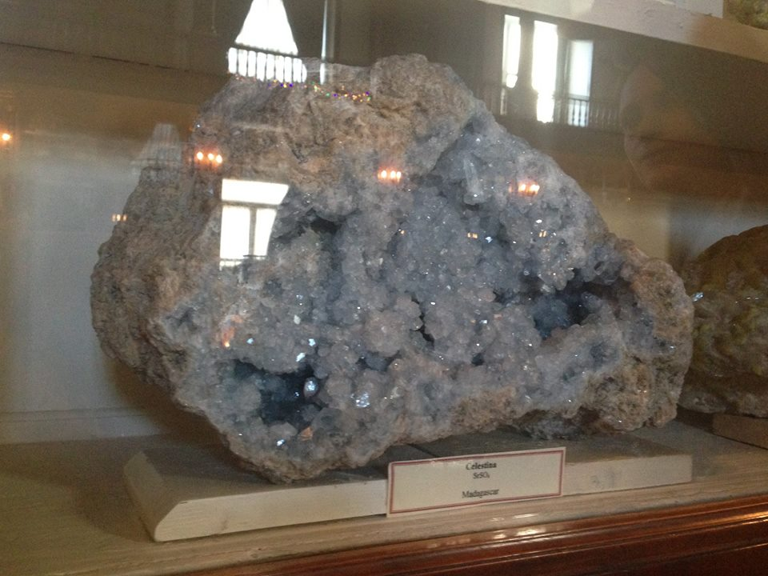
Celestine

It was really interesting visiting this museum because we have seen and learnt so many things about minerals and also we are so excited to be a part of this project. We are looking forward to meeting our new friends of the other countries that are sharing with us this Erasmus Plus experience.

Francesca Guidotti
Lorenza Migliardo
Nadia Salvemini

