UNIT PLAN: VOLCANIC HOTSPOTS

1. Justification:
The Canary Islands are the result of very long series of eruptions originating originally below the seabed. This hotspot is located in the east Atlantic and has been active for millions of years. The result of that activity is (are) the Canary Islands, some of which are still in a period of formation (formation period) and with active volcanism.

2. Objectives:
- To understand the origin of many oceanic islands around the world.
- To relate plate tectonics with oceanic hotspots and the formation of a series of islands through geological history.
- To relate the general characteristics of oceanic islands originating from oceanic hotspots with the characteristics of the Canary Islands.
- To understand why there are so many differences between the eastern and western Canary Islands.
- To learn about the most recent eruptions in the Canary Islands and produce an interactive presentation about those eruptions in groups.
- To create a Venn Diagram comparing the essential volcanic/geologic characteristics of the Canary Islands and the Hawaiian Islands.

3. Lesson plans:
Each of the lesson plans will focus on one the objectives above.

Lesson no. 1 What are oceanic islands? (55 mins.) | Objective/s: To understand the origin of many oceanic islands around the world.
Activities
Activity 1: Elicit prior knowledge | Duration: 2-3 mins.
Description: Ask Ss about what they might know about oceanic islands and their origin. Brainstorm and write down ideas on the board.
Activity 2: Introductory videos | Duration: 10 mins.
Watch short videos: https://www.youtube.com/watch?v=jG-Sy0y08GM; https://www.youtube.com/watch?v=9khk48fFc8Q; https://www.youtube.com/watch?v=t5go-78gCJU;
Activity 3: main concepts covered in the videos | Duration: 10
- In small groups, Ss try to elicit the main concepts conveyed in the videos.
- After 5 minutes, all the concepts are shared with the whole class and written on the board for everyone to see.
Activity 4: create a definition of oceanic hotspot islands. | Duration: 15 mins.
- In small groups, create a definition of what oceanic islands originated from hotspots are, including examples like the Canary Islands and others that will be shown on a world map (https://pubs.usgs.gov/gip/dynamic/world_map.html) to all the class, e.g.: Hawaiian Islands, Açores Islands, Galapagos Islands, Iceland, Reunion Island, etc.
- Share definition with the rest of the class.
- Come up with a unique and complete definition for all the class to have, e.g.: They are islands that originate from a volcanic plume that springs from the oceanic plate. This oceanic plate moves, and so move the islands with it. For that reason new islands are always being formed where the hotspot is, while older islands begin to slowly disappear due to erosion. Examples of such islands are: the Canary Islands, the Hawaiian Islands, the Açores Islands, the Galapagos Islands, Iceland, Reunion Island, etc.
Activity 5: Worksheet | Duration: 15 mins.
Give out each student a worksheet showing the world map and a space below where to write a definition of the oceanic hotspot.
Evaluation:
Check that all Ss cooperate in groups.
Check that Ss complete their individual worksheets. See map below.

Draw and Name the main hotspot islands on the map
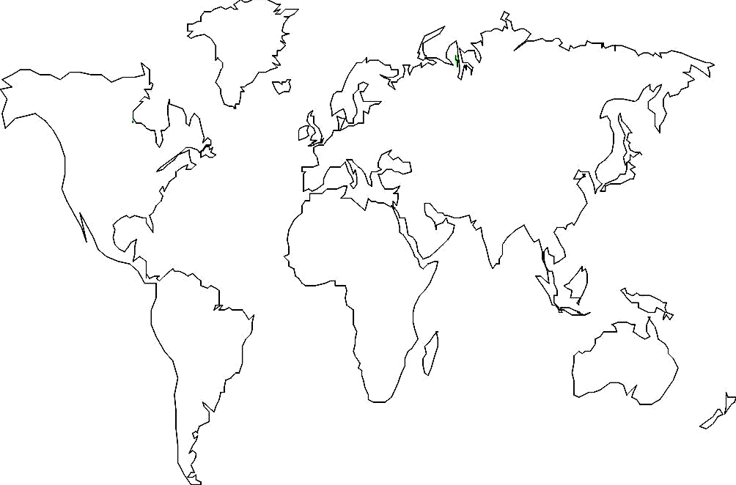

Definition of volcanic hotspot islands:

