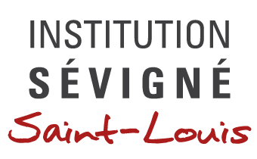

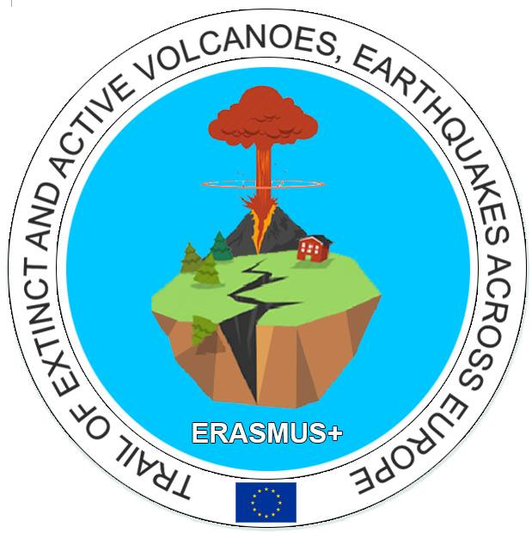**ERASMUS PLUS PROJECT: Trail of extinct and active volcanoes, earthquakes across Europe**

From November 13th to 17th, our school was very pleased to welcome 30 students and their teachers in Issoire, France, for a meeting.

On Monday, the organizing school welcomed the partners. The headmaster M. Veray gave a speech with all the students and teachers involved in the project. He insisted on the benefits of such projects for our students and our institutions in general and sincerely thanked all the participants for their commitment in the success of the project. He also underlined how this kind of cooperation is important in a period of trouble, of rising intolerance and questioning about Europe.

One of our students had made a short video to present the schedule of the week. After the traditional exchange of presents, foreign students and teachers agreed to spend some time in middle and high school classes to meet our students and present the project, their region, their school system…

At noon, the students and teachers gather in a large study room to present and watch the drama presentations about legends around volcanoes. Although the conditions weren’t ideal for such presentations (lack of materials…), our students enjoyed showing legends and other beliefs which are part of each country’s traditions.

In the afternoon, students and teachers went on an excursion in Montpeyroux, one of the most beautiful villages in France in order to visit the village itself but also to meet a local artist who makes jewels and decoration products out of volcanic rocks.

On Tuesday, the partners were taken to a medieval castle (Murol castle), partly made of volcanic rocks, and then to Lake Pavin, a very interesting place where scientists keep on wondering about the lake’s specificities and mysteries. The lake was a crater, and many legends exist around that place. Scientists still dive regularly to understand for example why the two layers of water never mix.

It was awfully cold but the view over the snowy landscape was fantastic. The most courageous of the group had a memorable snowball fight.

On Wednesday, the students attended lessons with their hosts while teachers had a work session. We discussed about the activities to come. The Polish team (coordinators) will publish the new schedule on the website. All the teams will put their drama presentations on a pen drive to collect all them in Pico during the next meeting, in order to publish them too.

We also talked about the next reports (term report in December and final report in June 2018).

Then, we all agreed about making videos (mixed with photos) about the goals achieved so far. In this third and last year of the project, we had the feeling it would be a great idea to focus on the benefits for students (with testimonies, interviews of students…). Each video must last maximum 5 minutes. These videos will be shared in Pico, for our next meeting at the end of February.

Last but not least, our students will also work on Powerpoint presentations to be shown in Pico: they’ll wonder about the influences of volcanoes in the development of our cultural identity.

After the work session, students were encouraged to mix and to discover Issoire through a sort of treasure hunt I had imagined. It aimed at making students work in multicultural teams and visit the city in an original way. Then, I wanted to correct the files and “elect” the best, most efficient team but unfortunately, only 4 teams out of ten gave me the file back.

In the afternoon, the students were free to spend time with their French hosts and discover their way of life.

On Thursday, all the partners were invited by the mayor in the city hall for a short ceremony. Presents were exchanged and a deputy mayor repeated how important such projects are, for all schools and for our cities too. She sincerely hoped everyone would enjoy this week in our beautiful region.

Then, we took a bus to go to Le Puy en Velay, a small city known for being a starting point to the Pilgrims’ route to Compostella. What’s more, many attractions in Le Puy were built on volcanic necks. That’s why we had a guided tour of Saint Michel’s chapel; a small but charming chapel built in the 10th century on one of these necks. Our friendly guide adapted the visit to us, making a quite short but interesting explanation, trying not to bore our students. Then, the students had a free tour in Le Puy en Velay, before coming back to Issoire.

On Friday, the group visited two “must-see” attractions in Auvergne: L’Aventure Michelin and the Puy de Dôme.

Next door to Clermont-Ferrand, Michelin factory museum is dedicated to the locally grown rubber empire. With a well-knowledged and helpful guide, we went through the history of the company, therefore the history of the tyre for almost two hours. It’s obviously amazing and interesting to learn how Michelin family developed the business in Clermont-Ferrand but also in the world all way back to tyres for bicycles.

Peaking at 1,485 metres, the Puy de Dôme is the tallest point of the Chaine des Puys, a volcanic mountain that counts no less than 80 volcanoes over 30 kms. This mountain can be reached year-round by an electric train, giving passengers a view of surrounding landscapes.

This document has been produced as my personal report of the meeting, based on my notes, my participation to the events and my colleagues’ report (for Tuesday and Friday activities)

The people mentioned are free to correct me if I haven’t quoted correctly our discussions and working agreements.

The French Coordinator

Claire CHAPOT CENZATO

[...]