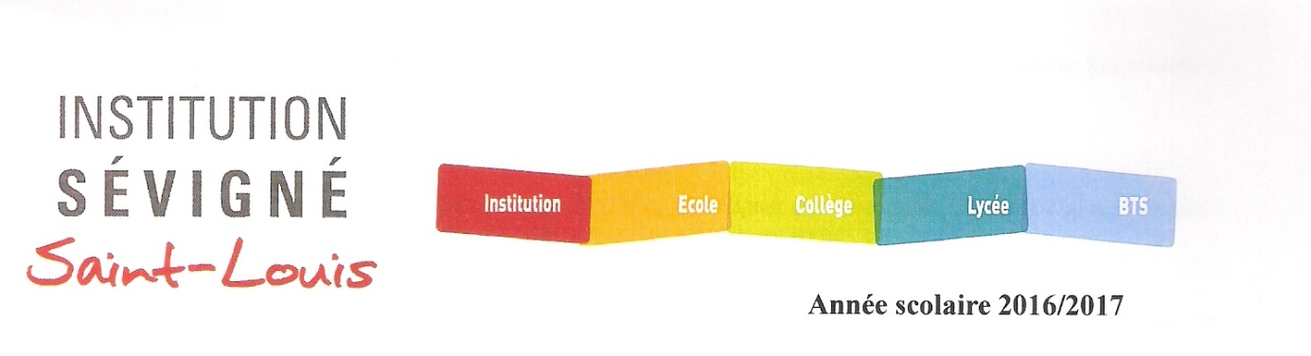

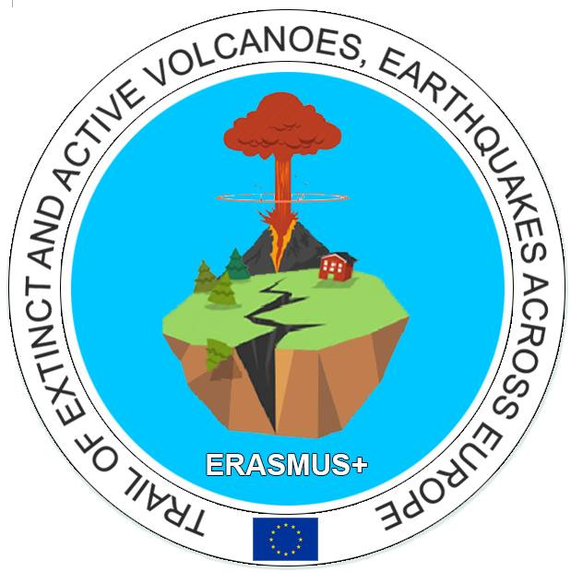ERASMUS PLUS PROJECT : Trail of extinct and active volcanoes, earthquakes across Europe

From October 3rd to 7th, four teachers of the partner schools met in Issoire, France, for a training week.

On Monday, the organizing school welcomed the partners. The mayor of Issoire was represented by Mrs Varischetti. Gifts were exchanged in the meeting room in the presence of the headmaster, Mr Veray who insisted on the benefits of such projects for our students and our institutions in general.

Then, a coordinators’ meeting started while the other teachers kindly accepted to meet some classes and present their school/ region/ country.
During the meeting, Mr Alfredo Ubierna introduced himself as the new spanish coordinator, which reassured everyone about the remaining months of the project. Nevertheless, the spanish team expressed their fear not to be able to find enough host families, their school being much smaller now, and fully vocational…
Then, coordinators faced difficulties setting dates for the next meetings in Spain and Poland. We finally agreed on March 2017 for Spain (5 students + 2 teachers) and September 2017 for Poland (5 students + 2 teachers).
Then , we planned the activities to carry on with our students by march 2017.
A competition about « risks & benefits of living in volcanic areas » may be launched, on either a local or national level, in various countries.
In November, at least 3 lessons must be made and then shared on the website of the project. Videoconferences between our schools will be organized soon.
Students will have to prepare posters about biodiversity : fauna & flora of our region.
Last but not least, students will have to think about various themes and get ready to work and exchange with the partners in Spain, the themes being Climate, geology, Chemistry and geography.
On Monday afternoon, a French art teacher organized a team activities based on our theme of volcanoes. Our work will be exhibited in the high school study room, which will help disseminate about the project.
Then another work session was held, mainly on the topic of the mobility to Antalya, Turkey.
Most schools repated their difficulties persuading parents to let their kids travel to Turkey, while Mr Mussafer Demirci, Turkish headmaster, insisted on having us all in his school. Mrs Madgalena SZEWCZYK, willing to find a compromise, suggested to organize the last meeting in Turkey rather than in Poland, with teachers only. This seemed satisfactory to us all. Anyway, the mobility to Turkey is still planned on the thirs year of the project, and our schools will wait for foreign ministry recommendations before making a decision.
OnTuesday 4th, the various teams were invited to take part in scientific lessons in the school labs with three teachers (Mr Bruno COUTAREL and Jerôme INACIO, both physics teachers, and Mrs Delphine GARNIER, biology-geology teacher)
With the help of an English teacher (Mrs Joëlle ROCHON), they tried hard to find out why volcanic rocks are red and then, they got acquainted with our scientific materials (softwares, polarizing microscopes…) and observed vocanic rocks such as basalt… with curiosity and interest.
In the afternoon, a guided tour of Issoire, with Mrs Myriam CHABRILLAT, was the occasion to observe Volvic stones in our local environment and architecture. (remains of the Medieval town, the abbey church built in the 12th century and typical of the Romanesque art in Auvergne and the Clock tower from where we could see the surrounding countryside with different sorts of volcanic landscapes.)
On Wednesday, a bus drove us all to Lemptegy volcano, known for having been exploited by men during about 60 years after the second world war. The partners could observe the inside of the volcano and realize human impact on our landscapes.
Then, we went to the Volvic stone museum dedicated to the importance of volcanoes in our local economy, since the beginning of the 20th century. The partners had also time to taste Volvic water, famous worldwide.
On Thursday, the teachers spent a nice but cold day in Vulcania, a quite recent scientific and fun park dedicated to Volcanoes. The visit was an opportunity to explore and offered a thrilling approach to volcanism. First of all, a model representing the surroundings enables the visitors to imagine what the region was like 9,000 years ago. Many exhibitions can be seen in the park, with the explanations of a local guide.
Some activities such as the “Abyss explorer” (discovery aquatic volcanoes), “Tornado alley” (scientific documentary) or “Dragon Ride” particularly caught the attention of the group.
On Friday 7th, all partners were taken by bus to the Volcano & Magma Lab in Clermont Ferrand. This lab was founded for fundamental researches in order to anticipate volcanic risks. One part of the lab is dedicated to pyroclastic surges which still remain a mystery… The goal being to evacuate populations after an eruption.
The group of teachers was shown the machines and materials to examine the chemical composition of volcanic rocks, to make models… Other robots enable to re-create the temperatures and pressures rocks undergo under the Earth surface. This lab, and its equipment, are unique in France.
The Portuguese team left during the lunch break.
The other partners had a guided tour of the city centre of Clermont-Ferrand. We were shown the Place de Jaude (a former maar), the Roman town, built on the slopes of the crater, the Opera house, the rue des gras climbing up to the Gothic cathedral and offering a superb view on the Puy de Dôme…
In the evening, a farewell buffet was offered at school, in the presence of a folkloric group. Local teachers and guests were invited to take part in traditional Auvergne dances.
The Polish team left after dinner, the Turkish, Spanish and Italian teams on Saturday.
This document has been produced as my personal report of the meeting, based on my notes, my participation to the events and my colleagues’ report (for Tuesday, Thursday and Friday activities)
The people mentioned are free to correct me if I haven’t quoted correctly our discussions and working agreements.
The French Coordinator
Claire CHAPOT CENZATO

